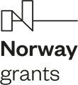 | NORWEGIAN FINANCIAL MECHANISM 2014-2021 | 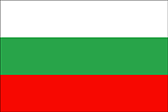

LIST OF CONTRACTS

№ | Project proposals | Project promoter | Project partner | Value/Amount | Duration
1. | “Stepping up efforts to prevent and combat violence against Roma women and women from minority groups facing discrimination, marginalisation and exclusion” | Foundation European Institute | The Ministry of Justice and Public Security – Kingdom of Norway.  Involved parties:  General Directorate National Police at the Ministry of Interior, Council of Europe, roma NGOs,  Kilden, the Saami parliament in Kingdom of Norway | 129 196.23 BGN  66 058,00 EURO | 4 months, but not later than 30th of April 2024
2. | “Hate crime workshop in Oslo”. | General Directorate National Police - MoI | Oslo police district, Kingdom of Norway | 30 269.91 BGN  15 477,00 EURO | 5 months, but not later than 30th of April 2024

